USER MANUAL

**ULTRASONIC**

**CUTTER**

MPInterconsulting

2400, Le Locle - Switzerland

https://www.mpi-ultrasonics.com

September 2023

TABLE OF CONTENTS

[Our Message 3](#_Toc145949975)

[Introduction 4](#_Toc145949976)

[Assembly 4](#_Toc145949977)

[Connections on the back of the generator 5](#_Toc145949978)

[For Ultrasonic Cutting tool we are using our ultrasonic 6](#_Toc145949979)

[Welding Generator – 1000W 6](#_Toc145949980)

[ULTRASONIC GENERATOR – Manual 8](#_Toc145949981)

[SAFETY INSTRUCTIONS 8](#_Toc145949982)

[GENERAL VIEW AND DIMENSIONS/mm/ 10](#_Toc145949983)

[- 1000W 10](#_Toc145949984)

[INSTALLATION & ENVIRONMENT 11](#_Toc145949985)

[Power supply 11](#_Toc145949986)

[Connections on the back of the generator 12](#_Toc145949987)

[Interface socket RS485 ModBus RJ 45 CONNECTOR: 12](#_Toc145949988)

[PIN DSUB I/O SOCKET 13](#_Toc145949989)

[Internal schematic of generator 14](#_Toc145949990)

[Interface Description 14](#_Toc145949991)

[OPERATION 16](#_Toc145949992)

[Operator elements and display on the front panel 16](#_Toc145949993)

[The LCD display 16](#_Toc145949994)

[Start Frequency 16](#_Toc145949995)

[Amplitude 16](#_Toc145949996)

[Time 17](#_Toc145949997)

[Peak power 17](#_Toc145949998)

[Energy 17](#_Toc145949999)

[Phase 17](#_Toc145950000)

[Scanning 17](#_Toc145950001)

[Phase Regulator 18](#_Toc145950002)

[Address 18](#_Toc145950003)

[Memory 18](#_Toc145950004)

[SETTING THE SOFTWARE 19](#_Toc145950005)

[ADJUSTING THE GENERATOR USING THE PC SOFTWARE 20](#_Toc145950006)

[PARAMETERS Tab 20](#_Toc145950007)

[Buttons: 21](#_Toc145950008)

[Sliders: 21](#_Toc145950009)

[SCANING Tab 22](#_Toc145950010)

[Tune Tab 23](#_Toc145950011)

[SLIDERS: 23](#_Toc145950012)

[Drop-down menu: 24](#_Toc145950013)

[SWEEP Tab 24](#_Toc145950014)

[SONICATOR Tab 25](#_Toc145950015)

[WELDING Tab 26](#_Toc145950016)

[OSCI Tab 27](#_Toc145950017)

[ERROR MESSAGES AND TROUBLESHOOTING 28](#_Toc145950018)

[OVERCURRENT 28](#_Toc145950019)

[OVERHEAT 29](#_Toc145950020)

[OVERLOAD 29](#_Toc145950021)

[OVERVOLTAGE 29](#_Toc145950022)

[HF OVERCURRENT 30](#_Toc145950023)

[EXT OVERHEAT 30](#_Toc145950024)

[MAINTENANCE 31](#_Toc145950025)

[WARRANTY 32](#_Toc145950026)

[SERVICE HOTLINE 32](#_Toc145950027)

[CE Declaration of Conformity 33](#_Toc145950028)

# Our Message

**1.** Our ultrasonic power supplies are compatible or easily modifiable to drive almost any piezoelectric ultrasonic transducer presently used/known in High Power Ultrasonics Industry, operating between 15 and 100 kHz (or wider) (of course, modifications in critical and demanding cases should be made in our labs). The same generator can operate on any frequency between 15 and 100 KHz (digital software settings, easy frequency selection in any range, and easy frequency window selection in any range).

**2.** We have the largest and modifiable frequency-window controls (almost any frequency interval, compared to 1 until 2 kHz from competition).

**3.** Our ultrasonic power supplies are using advantages of dynamic load power regulation between series and parallel resonance (capturing even wider frequency intervals). We can operate any piezoelectric, ultrasonic transducer in its resonant, fixed frequency regimes, in any numerically selected operating frequency interval, and in many forced, arbitrary frequency-modulated wideband regimes. Our generators are much better in many aspects when compared to the well-known ultrasonic generators from others. Our generators can be used on the same way as any other ultrasonic generator, and on many other unique ways. All presently known industrial and manual control options are available (manual, LCD front panel settings and controls, analog, PLC… Everything can be arranged as any other producer (or user) of ultrasonic generators is doing).

**4.** We implement (safe operating) internal scanning procedure in order to select the optimal operating regime and settings for certain ultrasonic transducer.

**5.** Our Ultrasonic Power Supplies have smooth power and amplitude regulation. We are applying limitation of maximal load power, maximal transducer amplitude and maximal output voltage on piezoceramics. We are applying overheating, short-circuit, over-current and over-voltage protections.

**6.** Our standard line of Ultrasonic Power Supplies is operating on European main supply voltage input, being tolerable to input voltages from 200 Vac until 240 Vac, 50/60 Hz. We can easily produce the same Power supplies for other input voltages (115 Vac 50/60 Hz). Internally, all of our standard Ultrasonic Power Supplies have stabilized, universal voltage SMPS for control and logic modules operating from 95 to 265 Vac. We can also (optionally) apply high power PFC input for customized Power Supplies.

# Introduction

Please read these operating instructions carefully and follow them before installing or commissioning your product. Failure to observe these instructions can present a risk to life.

Units may be operated by trained personnel only. Failure to comply with this will result in a loss of warranty rights. The device may only be operated and maintained by personnel who have read and understood this operating manual and are familiar with the applicable legal regulations for accident prevention and workplace safety.

# Assembly

In addition, ambient temperatures of over 30°C should be avoided. Choose a suitable location that will protect the device from moisture, water, excessive sunlight and heat.

**ATTENTION:**

• Choose a location that will prevent steam or any other aggressive vapors from penetrating the device.

• Over a period of time, chemically contaminated ambient air can lead to the device being irreparably damaged.

**ATTENTION:**

• For safety reasons, always disconnect the unit from the mains before changing fuses.

• Plug racks into earthed sockets only.

• Always replace blown fuses with new fuses of the same type.

• This should only be performed by qualified, skilled personnel.

## Connections on the back of the generator

Output of the HF voltage (possible to have different high voltage connectors)

**ATTENTION:**

• Only use cables specified by the manufacturer.

• Use only shielded transducer connection cables.

• Connect the shielding to the PE conductor on the generator side.

• Only use cables with sufficient cross-section.

• Minimum wires cross-section: 1.5 mm2

# For Ultrasonic Cutting tool we are using our ultrasonic

## Welding Generator – 1000W

|  |  |  |
| --- | --- | --- |
|  | **** | ** |

Factory settings of ultrasonic generator are already made, and user of this cutting tool can only apply **start/stop (=) on/off** black button, which is on the front panel of the ultrasonic generator case (meaning there is no need to connect ultrasonic generator to personal computer and make new settings). New software settings we can only apply if we change cutting sonotrode.

For safety reasons factory settings are limited only on 10 s of operating time, after start or “on” button is activated. If user needs to make longer cutting, it is necessary to press “on” button again.

Forced air cooling on the back side of ultrasonic converter should always be applied when cutting tool is operating. We apply 3 to 6 bar, filtered, dry airflow on room temperature (20°C or less).

# ULTRASONIC GENERATOR – Manual

# SAFETY INSTRUCTIONS

Before starting up your device, please read through the following instructions carefully, both for your own safety and for the safety of the device.

Keep this manual where it can be readily accessed by all systems users.

###### Installation is to be carried out by qualified technical personnel only!

This ultrasonic generator is to be operated by properly trained personnel only!

Due to the way it operates, **additional** safety measures must be taken if the device is to be used in areas posing an explosion risk.

The electromagnetic compatibility corresponds to the standards and regulations listed in the specifications. All necessary settings were either made in the factory or are described in this handbook.

However, should problems occur on start-up, please do not make any prohibited adjustments to the device, as this would endanger your warranty rights. If in doubt, please contact our technical service staff.

Please contact our technical service if at all in doubt. Please see the last page.

Inspection or diagnostic work inside the device may only be carried out to the extent described and, as with the electrical connection should only be performed by skilled personnel. When performing such work, the ultrasonic generator must be completely disconnected from the main power source. (Unplug the mains connection).

The device must always be disconnected from the mains before cleaning or when installing/uninstalling an option. Do not use liquid cleaners or sprays. Only use a damp cloth.

Inputs or outputs that are used for controlling or monitoring purposes should be twisted and shielded. The device must not be near electrically charged components or cables.

The shielding should be connected to the generator ‘s earth on one side of the generator.

Attention: All connections for the signal or control lines are galvanically connected to the generator. Always observe any warnings or instructions provided on the device itself.

The platform for the device must be sufficiently stable, as the device being jolted or falling could cause severe damage.

Ensure that the power supply specifications given on the device are met.

Only those transducers which have the correct frequency, power output and dimensions may be used with this generator.

HF cables from the generator to the transducer as well as mains cables to the generator may not be rolled up if they are too long. Instead, they must be shortened to the required length due to the risk of overheating.

With the exception of the permitted tasks listed in the handbook, you should never attempt to repair or modify the device yourself.

###### In the following cases you should disconnect the device from the mains and contact a qualified service engineer:

* **If the mains cable or plug is damaged**
* **If liquid has penetrated the device**
* **If the device has fallen over or the housing is damaged**
* **If the device displays noticeably different behavior than standard operation**

**ATTENTION: Repairs and modifications may only be carried out by competent, skilled personnel.**

### GENERAL VIEW AND DIMENSIONS/mm/

## 1000W

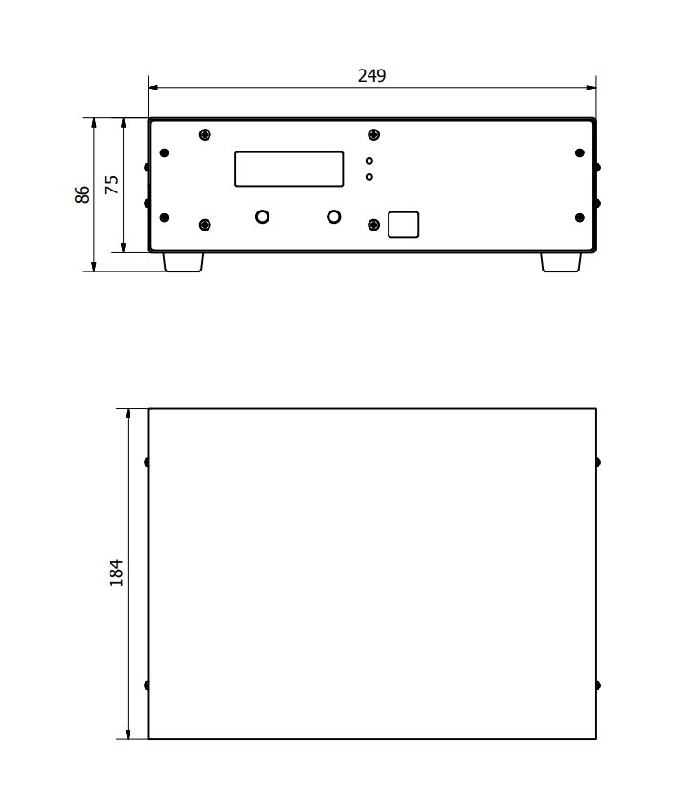

# INSTALLATION & ENVIRONMENT

Choose a suitable location that will protect the device from moisture, water, excessive sunlight and heat. The selected location for the device should be in an area where ambient temperatures do not exceed 40°C.

If the generator cannot dissipate the heat sufficiently, it will display an error message due to excess temperature (see also the “OVER TEMPERATURE” error description).

###### ATTENTION: • Choose a location that will prevent steam or any other aggressive

**vapours from penetrating the device.** Ambient temperatures of over 30°C should be

avoided.

###### Over a period of time, chemically contaminated ambient air can lead to the device being irreparably damaged.

## Power supply

The ultrasonic generator draws its power (210-250VAC/50-80Hz) via the connection cable with **Power socket.**

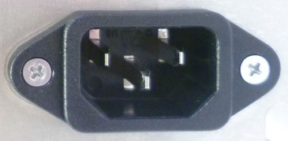

It has an external main fuse :

|  |  |
| --- | --- |
| **Power** | **Fuse** |
| **1000W** | 6.3 A/250VAC |

###### ATTENTION:

* **For safety reasons, always disconnect the unit from the mains before changing fuses.**
* **Plug racks into earthed sockets only.**
* **Always replace blown fuses with new fuses of the same type.**
* **This should only be performed by qualified, skilled personnel.**

## Connections on the back of the generator

**HF OUTPUT: HF Output connector is a Lemo : ERA.1S.250.CTL**

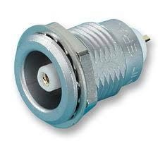

**ATTENTION:**

* **Output voltage could be between 600V and 1200V AC.**
* **Only use cables specified by the manufacturer.**
* **Use only shielded transducer connection cables.**
* **Connect the shielding to the PE conductor on the generator side.**
* **Only use cables with sufficient cross-section.**
* **Minimum cross-section: 1.5 mm2.**

## Interface socket RS485 ModBus RJ 45 CONNECTOR:

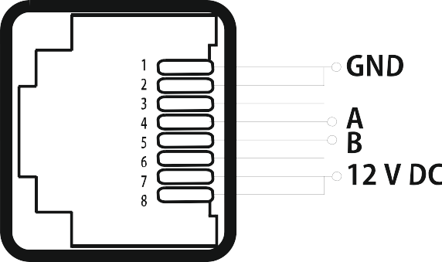

|  |  |  |  |
| --- | --- | --- | --- |
| **PINS** | | **DESCRIPTION** | |
| 1 | GND | |
| 2 | GND | |
| 3 | N/C | |
| 4 | A | |
| 5 | B | |
| 6 | N/C | |
| 7 | 12 V DC | |
| 8 | 12 V DC | |

# 

# PIN DSUB I/O SOCKET

**Assignment of the 15-pin DSUB interface socket**

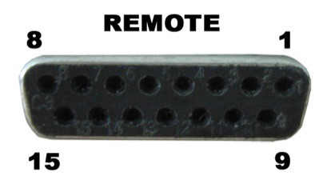

|  |  |  |
| --- | --- | --- |
| **PIN No. on DSUB SOCKET**  **Interface X1** | **Signal name** | **Description** |
| 1 | +12 VOLT OUT | 15 Volt for external use |
| 2 | POUT | Output 0 – 10 Volt = Power output 0 – 100 % |
| 3 | P-EXT.-IN | Input 0 – 10 Volt for power control |
| 4 | GND | Internal Ground for analog input and output internal (GND) |
| 5/9 | HF-DA-ERROR | Common sigmal for HF-DA-ERROR |
| 6 | HF-DA | Optocoupler output “HF-DA” |
| 7 | ERROR | Optocoupler output “ERROR” |
| 8 | A | ModBus over RS485 “A” signal |
| 9/5 | HF-DA-ERROR | Relay root (shared) for “HF-DA” and “ERROR” |
| 10 | B | ModBus over RS485 ”B” sigmal |
| 11 | Not connected |  |
| 12 | Not connected |  |
| 13 | FS-24 V | Remote START/STOP control input (with 10 – 24 Volt) |
| 14 | GND | internal (GND) |
| 15 | GND | internal (GND) |

**ATTENTION: A shielded control cable must always be used for the interface.**

## Internal schematic of generator

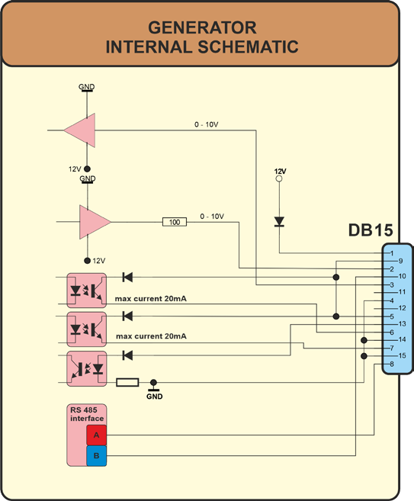

## Interface Description

**1.) Signal “+12 Volt Out” DSUB PIN 1**

A voltage of 12 V is available at this output. This signal can be loaded with max. 100 mA. It can be used as supply voltage for the functions “HF-DA” , “Error”, “FS-24 V”, “P-EXT.-IN”.

Reference signal is GND.

###### 2.) Signal “POUT” DSUB PIN 2

At this output a voltage proportional to the power output of between 0 and 10 V (= 0 – 100 % power output) is available.

Reference point = “GND”.

###### 3.) DSUB PIN 3

By connecting a voltage between 0V and 10 V, the output of the generator can be set to between 0% and 100% of its nominal amplitude or power. **This is only possible when the value of parameter “ POWER SET POINT” is set to 0 from the LCD or PC software.**

Reference signal is “GND”.

###### 4.) Signal ”GND” DSUB PIN 4

**5.) Signal “HF-DA ERROR” DSUB PIN 5/9**

Shared in/output for the internal optocoupler “HF-DA” and “ERROR” (these PINs are connected internally).

###### 6.) Signal “HF-DA” DSUB PIN 6

If the ultrasonic generator start, and is emitting HF voltage (i.e. there is no ERROR), an internal optocoupler is Switched ON. (between PIN 6 and PIN 5/9)

The “root” of this optocoupler leads through to a PIN 5/9 (these pins are connected internally) in the DSUB socket.

A voltage connected to Pin 5/9 can be switched through (max. 36 VDC / 20 mA).

###### 7.) Signal “Error” DSUB PIN 7

This is the output of an internal optocoupler (root to PIN 5/9).

This optocoupler reports generator ERROR in one of the following cases:

* 1. Overcurrent
  2. Overvoltage
  3. Overheat.

An external voltage connected to “HF-DA-Error” can, of course, also be switched through here (max. 36 VDC / 20 mA).

###### 8.) Signal “A” DSUB PIN 8

A signal of RS 485 interface

###### 10.) Signal “B” DSUB PIN 10

B signal of RS 485 interface

###### 11.) NC.

**12.) NC**

**13.) Signal “FS-24 Volt” DSUB PIN 13**

Switching on the generator (Ultrasound On) by connecting a voltage between 10 – 24 Volt between PIN 13 and GND (PIN 4,14 or15).

###### 14.) Signal “GND” DSUB PIN 14

**15.) Signal “GND” DSUB PIN 15**

# OPERATION

## Operator elements and display on the front panel

**LED-on:** Lights up when the device is being supplied with mains voltage correctly and the power switch is ON

**LED-error:** Lights up in the event of an error

**ON/OFF button:** The generator is switching on and off by pressing this button.

**Menu - Encoder / Select:** For setting and entering values

# The LCD display

## Start Frequency

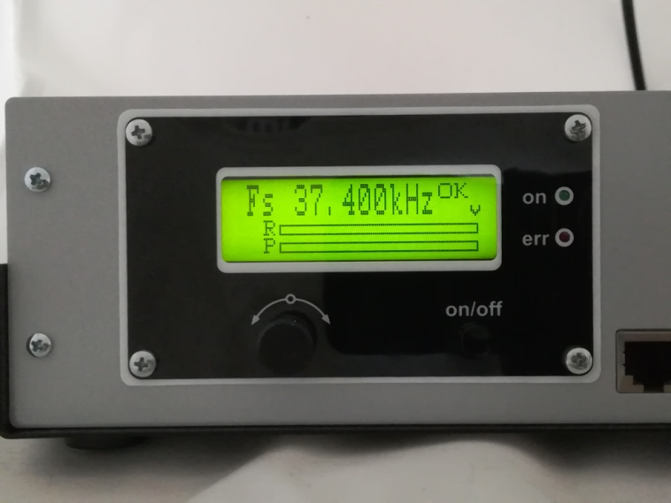Here you can see and set the initial operating frequency. To edit the value of the frequency, you need to push once the encoder knob and by turning left or right adjust the value of the starting frequency. After pushing the knob you will notice that the letter “v” over the right corner of the dynamic bars will become ”j”.

**R** dynamic bar – this the phase regulator actual value.

**P** dynamic bar – this the output power actual value.

## Amplitude

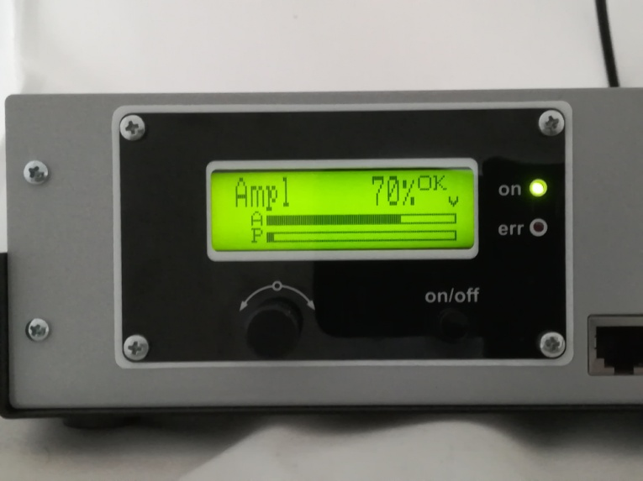Display shows the set value of output amplitude(output voltage) and its performance on "A" bar. From 0% to 100% of nominal output amplitude. During initial testing of new sonotrodes, set the amplitude to some low value (example: 50% to 60%).

To edit the value of the amplitude, you need to push once the encoder knob and by turning left or right adjust the value. After pushing the knob you will notice that the letter “v” over the right corner of the dynamic bars will become ”j”.

**A** dynamic bar – this the amplitude(output voltage) actual value.

**P** dynamic bar – this the output power actual value.

## Time

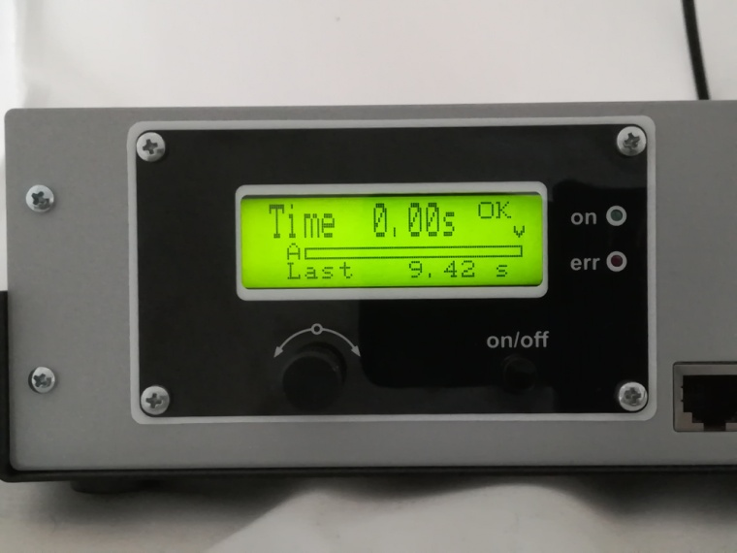

**Welding process will stop after given Time interval.**

## Peak power

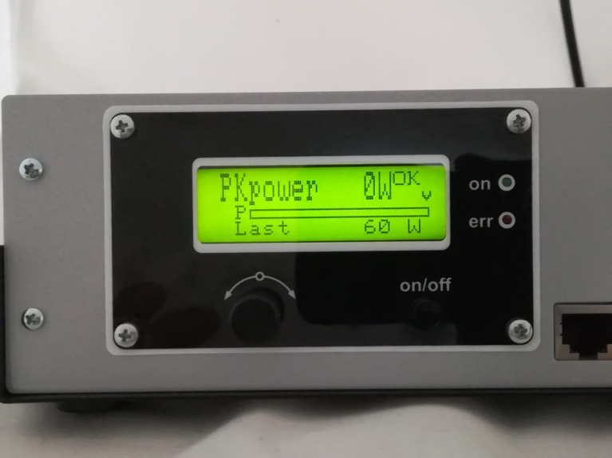

**“Welding by limiting the Peak power on the load”. Welding process will stop when Peak power is reached.**

## 

## Energy

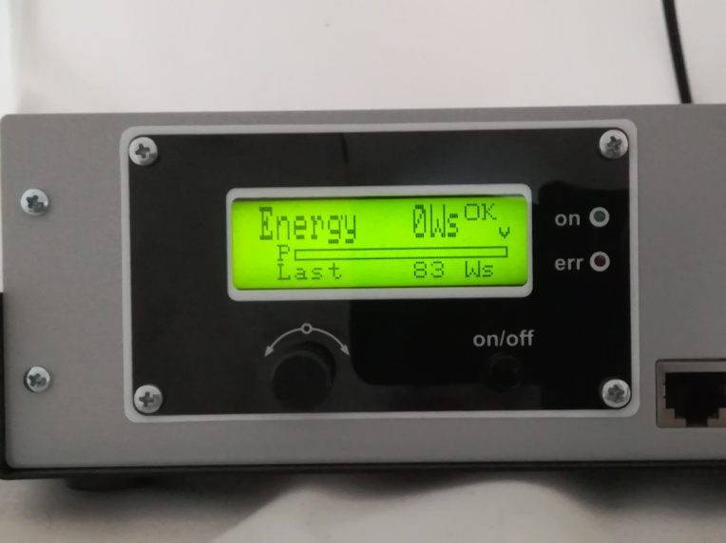

**“Welding by limited amount of Energy” which should be sent to a load. Welding process will stop when given amount of Energy is delivered to a load.**

## 

## Phase

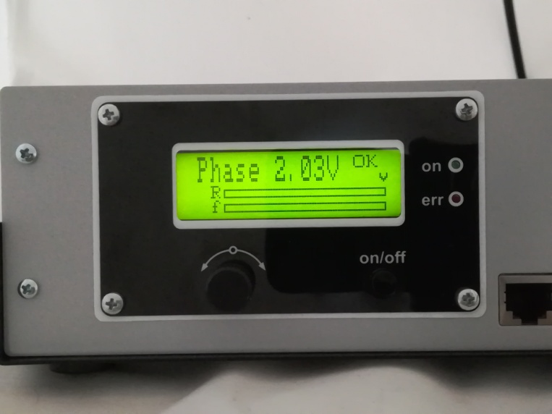

Here you can see and set the operating phase. To edit the value of the phase, you need to push once the encoder knob and by turning left or right adjust the value of the starting frequency. After pushing the knob you will notice that the letter “v” over the right corner of the dynamic bars will become ”j”.

**R** dynamic bar – this the phase regulator actual value.

**f** dynamic bar – this the phase actual value.

## Scanning

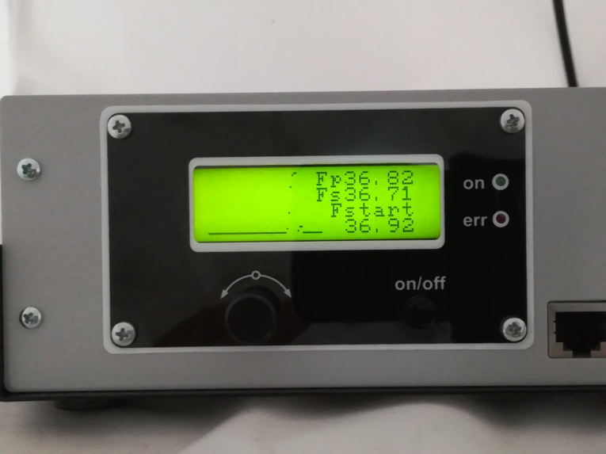After pressing the ON/OFF button, the generator scans at a low power in the interval from fstart to fstart-scanning range(you can set scanning range only in the Labview software). If in this interval persists ultrasonic resonant load, than the generator shows it’s parallel frequency fp and serial frequency fs. It also shows recommended fstart on the bottom(which is fp + 100 Hz).

In graphical view the resonant curve is shown.

## Phase Regulator

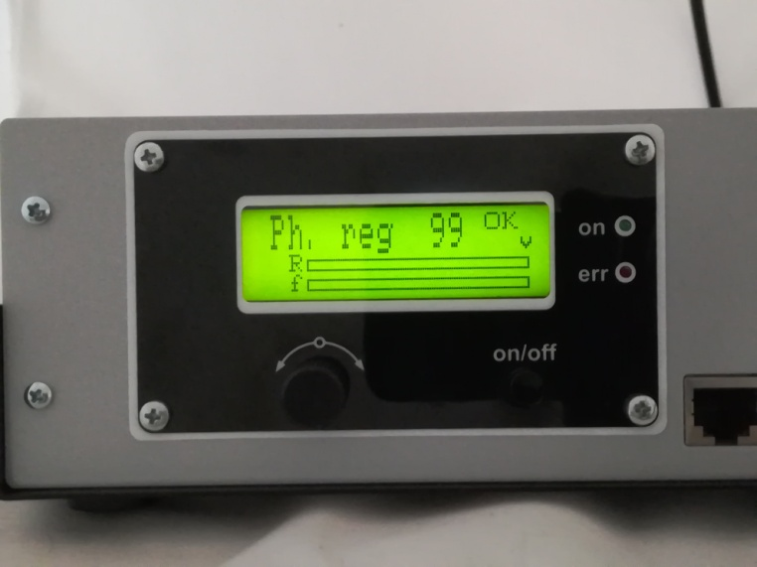**Integral Constant - ki**

Here you can set the operating Phase Regulator Integral Constant. To edit the value of the Phase Regulator Integral Constant, you need to push once the encoder knob and by turning left or right adjust the value of the starting frequency. After pushing the knob you will notice that the letter “v” over the right corner of the dynamic bars will become ”j”.

**R** dynamic bar – this the phase regulator actual value.

**f** dynamic bar – this the phase actual value.

*You need to know that lower value makes the regulator faster, and the opposite – higher value makes the regulator slower.*

## Address

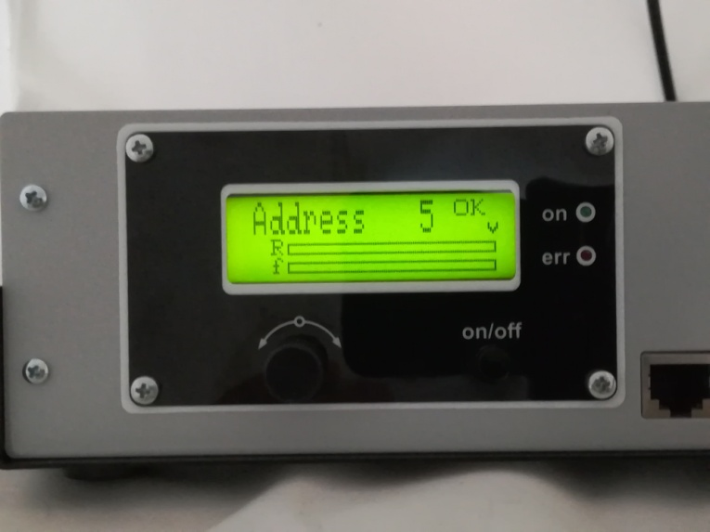Here you can see and set the operating Modbus address. To edit the value of the address, you need to push once the encoder knob and by turning left or right adjust the value of the starting frequency. After pushing the knob you will notice that the letter “v” over the right corner of the dynamic bars will become ”j”.

**R** dynamic bar – this the phase regulator actual value.

**f** dynamic bar – this the phase actual value.

## IMG_20190810_174011.jpgMemory

To save all parameters or changes in the EEPROM of the generator, you need to push once the encoder knob and by turning left or right memorize all settings. After saving is done the initial window **Start Frequency** appears . After pushing the knob you will notice that the letter “v” over the right corner of the dynamic bars will become ”j”.

**R** dynamic bar – this the phase regulator actual value.

**f** dynamic bar – this the phase actual value.

# SETTING THE SOFTWARE

**The generator has a standard communication interface ModBus RTU over RS 485. To connect to a PC you should use MPI adapter USB or RS 232 to RS 485 optically isolated.**

###### Before starting the software for the generator, you need to follow and execute the following steps

**All relevant files are here:**

**<http://www.mastersonics.com/documents/mmm_basics/mmm_power_supplies/AMMM/AMMM+W+S/>**

**Install the Generator software, which is here:**

|  |  |  |  |
| --- | --- | --- | --- |
|  | https://www.mastersonics.com/images/explorer/unknown.png | [SONICATOR WELDING software RT2018\_27092021.zip](https://www.mastersonics.com/documents/mmm_basics/mmm_power_supplies/AMMM/AMMM+W+S/SONICATOR%20WELDING%20software%20RT2018_27092021.zip" \t "_blank) | 369.8 Mb |

**Connect the USB adapter to your system and if needed install driver for USB to RS485 adapter using FTDI chip FT232RL - you can download**

**the latest version, updated for your OS from here:**

**<https://www.ftdichip.com/Drivers/VCP.htm>**

###### Now you are ready to start the executable file ("C:\Program Files (x86)\Sonicator welding modbus\Sonicator welding modbus 12\_22\_2019 v1.00.exe") of the software of your generator.

1. First action (regarding all generators and all software we are offering), after activating specific generator software, is to connect your PC with ultrasonic generator using our RS485-USB adapter.
2. Then you need to select and activate proper operating COM port from the generator software tabs. This will open communication between your PC and your ultrasonic generator.
3. Then you need to select initial setting conditions regarding expected frequency range.
4. Then you need to make Scanning to see where ultrasonic load can operate.

# ADJUSTING THE GENERATOR USING THE PC SOFTWARE

## PARAMETERS Tab

1. **Start with “Parameters” tab**, and select proper COM port. NOTE: Every new generator has 5 modbus address by default.

To connect the generator to the labview software we need to cover the following three conditions:

* 1. To know the Modbus address of the generator. Every new generator has 5 modbus address by default.
  2. To know the exact COM port where the USB to RS485 driver is installed. Go to the Device Manager of your PC and find the USB Serial Port(The USB adapter must be plugged to one of the USB ports of your PC).

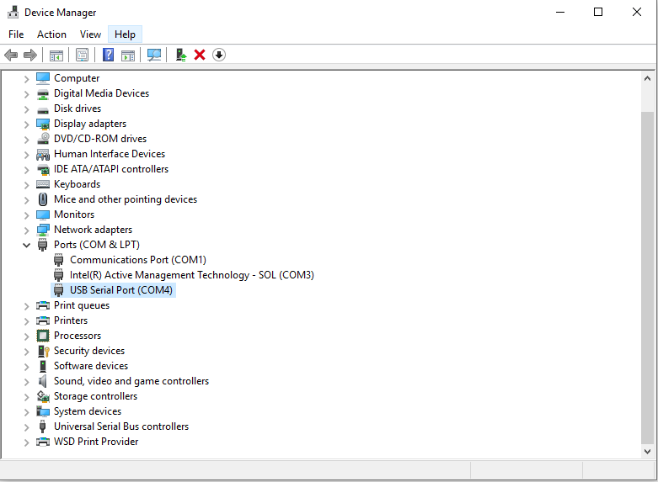

* 1. The communication baud rate is 115 200.

At this moment you will have NO connection (initialized by **not** blinking in green the **connection**

After validating the com port you will have connection (initialized in lime green blinking of the **connection**

initialization).

* 1. Select the ModBus address of the generator you want to connect to. Every new generator has default ModBus address 5. You will find the address of the generator you will drive on the display of the generator. Check if the value of the address in “Slave address” field is correct and if needed change it with the correct value shown on the display.
  2. Select the correct Nominal Power of the generator (indicated on the lable of your device).

#### Press “RESCAN”. **Connection** (lime-green) light should be blinking. Now you are connected to the generator with the selected address.

Save this setting in generator’s EEPROM Memory by pressing button WRITE.

1. 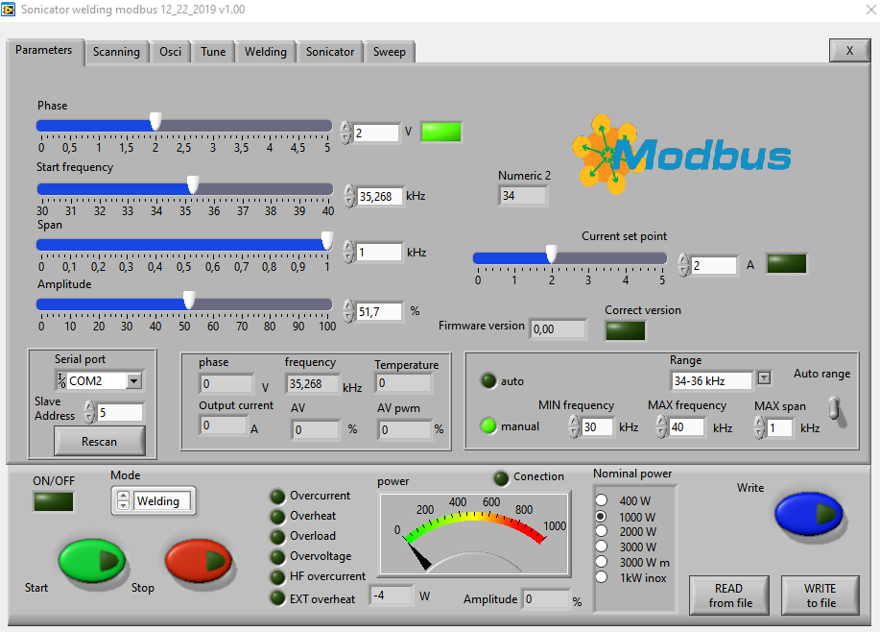If the generator is connected to the software, the indicator light CONNECTION blinks green.
2. After pressing the button RESCAN you have all parameters and settings from the generator uploaded in Labview software.

### Buttons:

**RESCAN** – By pushing RESCAN all

parameters saved in the generator’s memory will upload into Labview software.

**WRITE -** By pushing WRITE all parameters set in Labview software will download into the generator’s memory.

**START -** By pushing START the generator starts the working cycle.

**STOP -** By pushing STOP the generator stops working.

**WRITE TO FILE -** WRITES all parameters set in Labview software into a text format(.txt) file on the hard disk of the computer.

**READ FROM FILE -** READS all parameters from text format(.txt) file on the hard disk of the computer and downloads the data into the generator.

### Sliders:

**Phase–** sets (in Volts) actual working phase(the best position is between 2 and 2.5).

**Start Frequency –** sets the start frequency of the generator.

#### If the transducer is 20 kHz choose for Fstart set a little bit higher of 20 -for example 20,5. Save this setting by pressing button WRITE.

**Current Set Point –** sets the maximum ouput HF current to the transducer.

**Span –** sets the working window, where the generator seeks the working frequency of the transducer, because the working frequency could change because of loading the transducer and/or the temperature of the transducer.

**Amplitude –** The actual voltage over the transducer (in % of the maximum allowed)

**Scanning range –** This is the frequency range where the generator executes the scanning procedure, starting from the Fstart and going down to Fstart-Scanning range(in ex. Fstart=20kHz, Scanning range=2kHz – the generator will start at 20kHz and will shift the frequency down to 18kHz).

## SCANING Tab

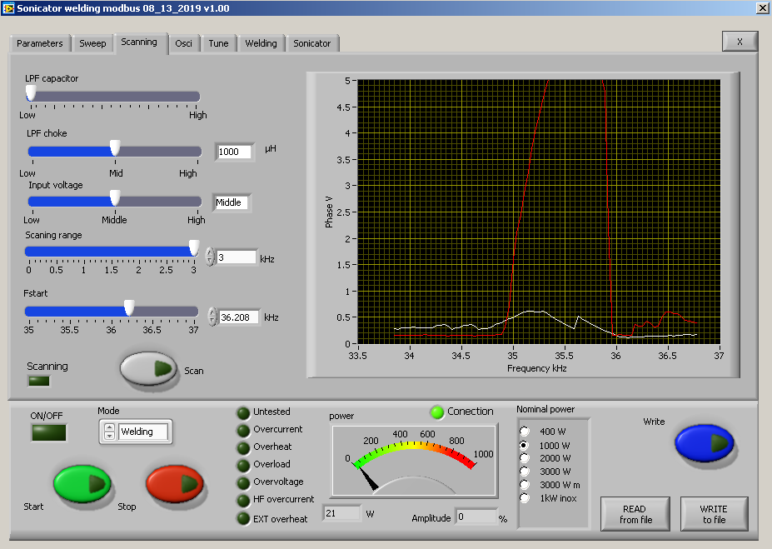

The generator has Scanning function which is very powerful instrument for the operator.

Here you can discover the phase and current characteristic of the exact load. It is shown graphically in a window in Scanning tab.

1. You need to check first if the **Start frequency** and the **Scanning Range** in **Parameters tab** are set properly.

#### Press the SCAN button. The scanning procedure starts. There is a drawing consisting of phase characteristics (red line) and current characteristics (white line). It should be similar to the picture with well-defined phase feature. This diagram shows the actual operating parameters of the transducer. If necessary, pick new Fstart and Scanning range (in Parameters tab).

You will see an active operating area of transducers, like on the picture above. It starts a scanning procedure on low power that indicates the Phase characteristic (red line ) and consumed output current (white line). **For F-start you need to select, the value closed to the working frequency of your transducer, which is where the red line just starts to grow+100 Hz**(on this diagram 36 kHz+100Hz = 36.100 kHz).

Now, you also to select the SPAN value. This is the window where the generator will operate and will seek for the transducer. The Span should be selected at least the difference between the value where the red line goes down (35 kHz) and the value where the red line goes down (36 kHz)+ 300 Hz(in this example Span= 36 kHz-35 kHz +300 Hz= 1.3 kHz).

**LPF Capacitor - Output Low pass filter capacitor –** the generator has selectable low pass filter on the output for better matching the load. It consist of LC components.You need to set the higher value of the LPF Capacitor when your transducer is with low capacitance, and opposite - you need to set lower value of the LPF Capacitor when your transducer is with high capacitance.

**LPF Choke – Output Low pass filter Inductance -** the generator has selectable low pass filter on the output for better matching the load. It consist of LC components.You need to set higher value of the LPF Choke(inductance) when your transducer is with low impedance(consumes high current), and opposite - you need to set lower value of the LPF Choke when your transducer is with high impedance.

**Output Voltage –** The main HF transformer has three levels of transformation ratio. Switching between the different levels, the maximal value of the voltage supplied to the transducer is changed. Lower value is needed when the load is with high Q factor(high mechanical amplification).

**Scanning range –** This is the frequency range where the generator executes the scanning procedure, starting from the Fstart and going down to Fstart-Scanning range(in ex. Fstart=20kHz, Scanning range=2kHz – the generator will start at 20kHz and will shift the frequency down to 18kHz).

**FStart- Start Frequency –** sets the start frequency of the generator.

#### If the transducer is 20 kHz choose for Fstart set a little bit higher of 20 -for example 20,5. Save this setting by pressing button WRITE.

## Tune Tab

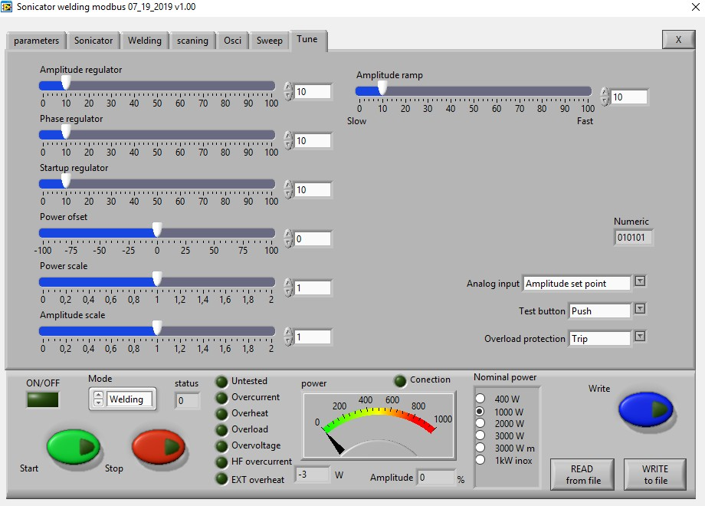

### SLIDERS:

**Amplitude Regulator** – This is the Ki of the output voltage regulator(amplitude)

**Phase Regulator** – This is the Ki of the output current regulator(amplitude), in case it is selected CURRENT Mode in Regulator Mode Selection Menu.(Phase Mode is the default mode).

**Startup Regulator** – This is the ramp that sets the speed of shifting the frequency down- big ramp set value – slow speed, small ramp set value – fast speed.

**Power Ofset** – internal use only  **Power Scale** – internal use only  **Amplitude Scale** – internal use only

**Amplitude Ramp** - This is the ramp that sets the speed of growing the amplitude- big ramp set value – slow speed, small ramp set value – fast speed.

### Drop-down menu:

**Analog Input – here select what to assign to the analog input of the DSUB connector:**

* + **Amplitude Set Point** – 0-10V – sets the measure of the amplitude 0-100%.
  + **EXT(external) Temeperature**– 0-10V – If the signal exceeds 5V=50%, the protection is activated and the error lamp lights in red.

###### Test Button –

* + **Push -** the generator works only and during pressing and as long as you hold pressed the button. After releasing the button the generator stops.
  + **Latch -** it works on toggle-toggle regime – by pressing the button once – it starts the generator, by pressing the button for the second time – it stops working.

###### Overload Protection – you can select the type of the overload protection:

* + **Trip –** when overload occure, the generator stops and the red lamp “Overload” lights.
  + **Warning-** after overload occure, the generator keeps on working, but after pressing the button STOP the red lamp “Overload) will light up warning you to check the load. This option is for loads with poor phase characteristic, to avoid frequent stopping of the generator during operation.

## SWEEP Tab

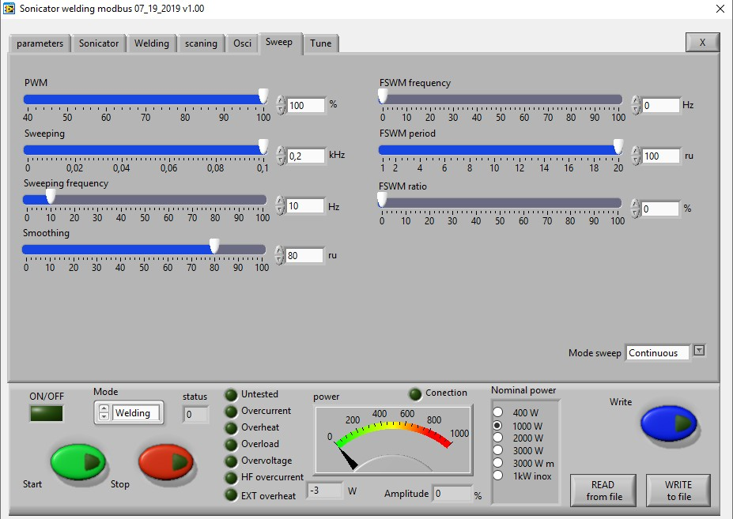

**PWM–** Set the PWM ratio in %, but on 100% the ON/OFF regime will turn off.

**Sweeping–** This the depth of the artificial sweeping frequency in three possible modes: Continuous – no sweeping; AMMM – semi-random sweeping; Periodic – periodic sweeping.

**Sweeping frequency –** Here you can set the desired sweeping frequency in *Hz*.

**Smoothing –** This changes the shape of the sweeping frequency from rectangular to similar to sinusoidal.  **FSWM frequency(Frequency Shift Width Modulation Frequency) –** Set the additional frequency with wich value to change the carrier frequency up. i.e carrier frequency 28.5 kHz + FSWM frequency 0.5 kHz= 29 kHz.  **FSWM period –** This modulation has a period that could be set in *ms*.

**FSWM ratio –** This modulation has a ratio that could be set in *%*.

## SONICATOR Tab

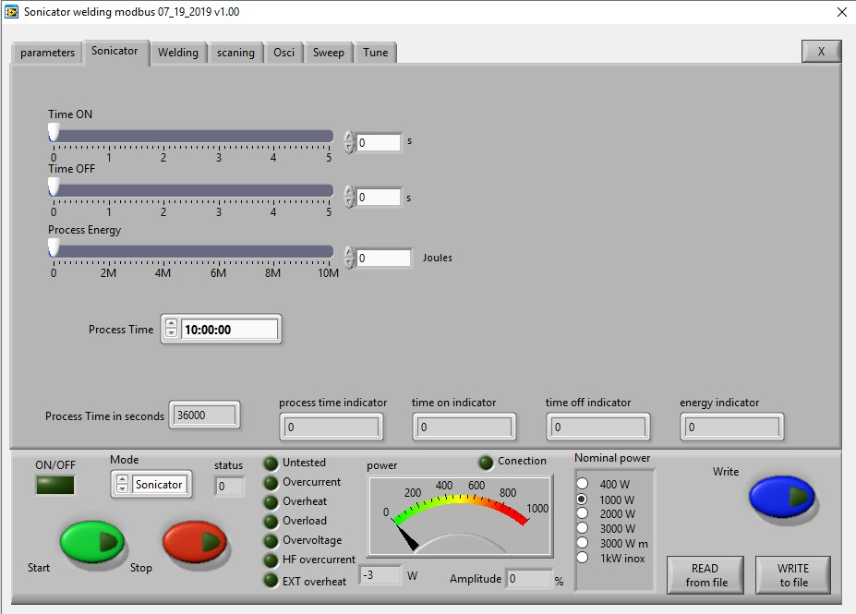

**Time ON –** Set the operation time of the generator in Sonicator mode.  **Time OFF –** Set the non-operation time of the generator in Sonicator mode.  **Process Energy –** Here you can set the delivered to the load energy.

## WELDING Tab

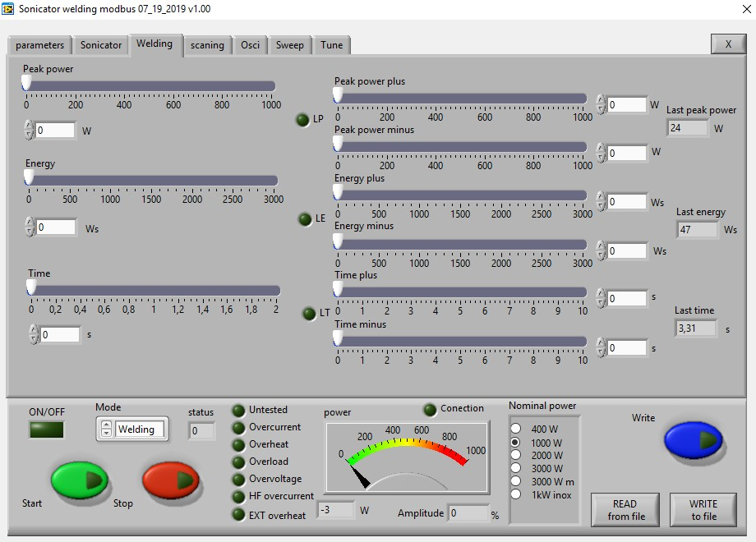

###### Welding by time:

**Time** – time when the generator is on (in seconds)

**Time plus** – shows the additional safety time. This maximum duration of the control signal (in seconds)

**Time minus** – minimum duration of the control signal (in seconds)

***Note****: If entered a control signal from external control unit (PLC) out of limits* ***Time Plus*** *and* ***Time minus****, the LED will light in red and an error message* ***Limit Time*** *will be displayed.*

**Last time** - duration of the last working cycle (in seconds)

###### Welding by energy:

**Energy** – setting of nominal energy during the welding process (in Ws). If the setting is different from 0 and the generator reaches the set value the generator automatically stops.

**Energy plus** – maximum allowed energy reached during the welding process. (in Ws)

**Energy minus** – minimum allowed energy reached during the welding process (in Ws)

***Note****: If the energy during the welding process is out of limits* ***Energy Plus*** *and* ***Energy Minus****, the eroor LED will light in red and an error message* ***Limit Energy*** *will be displayed.*

**Last Energy** – energy of the last working cycle (in Ws)

###### Welding by peak power:

**Peak Power** – setting of the peak power (in W). If the setting is different from 0 and the generator reaches the set value of the peak power, the generator automatically stops.

**Peak plus** – maximum allowed peak power reached during the welding process (in W)

**Peak minus**– minimum allowed peak power reached during the welding process (in W)

***Note****: If the Peak Power during the welding process is out of limits* ***Peak Plus*** *and* ***Peak minus****, the LED will light in red and an error message* ***Limit Peak Power*** *will be displayed.*

**Last pk Power** – peak power of the last working process (in W)

## OSCI Tab

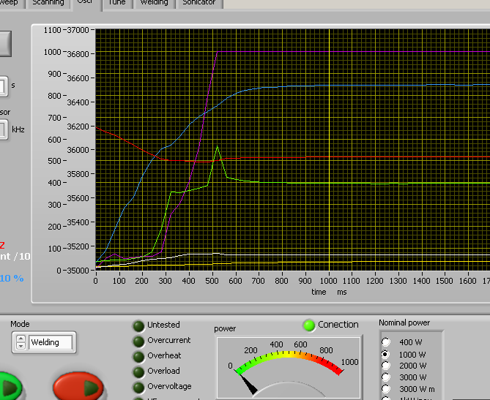

There is an inserted function for **recording data** – frequency, output current, phase, amplitude, power and PWM. Select the duration of the record in the field “**Sampling time**” – in seconds. The recording starts by START of the generator and ends when the selected time to write is finished. After recording is finished, when the button read is pressed, the data from generator is uploaded in the Labview software and is visualized graphically.

# ERROR MESSAGES AND TROUBLESHOOTING

#### When error event occurs the error LED will ligh up in red.

**All types of error messages will be cleared after restarting the generator.**

The following error messages may appear on the display:

## OVERCURRENT

– Overlimitted high current is flowed through the power transistors

The electronic overcurrent trigger has detected an error.

###### Possible causes:

* Short circuit in the cable or transducer
* Starting frequency selected is too HIGH
* Starting frequency selected may be too LOW
* There is a problem with the transducer.

###### Troubleshooting:

* Switch on the generator without the transducer connected. If OVERCURRENT message does not appear on the display, this means that the generator is in good working condition.
* Check the cable between the generator and the transducer.
* Check the transducer for short circuit.
* Change and set properly the starting frequency, if it is not in range as described in

this manual(see ADJUSTING THE GENERATOR).

Error message:

## OVERHEAT

The electronic overheating trigger has detected an error.

**Possible causes: ·** Not enough space around the generator.

* Ambient temperature is too high.
* The fan is dirty or malfunctioning.

Error message:

## OVERLOAD

– the generator cannot find the resonance frequency of the transducer inside the choosen frequency window.

###### Possible causes:

* Starting frequency selected is too HIGH
* Starting frequency selected may be too LOW
* Span selected may be too LOW.
* The cable between the generator and the transducer is broken
* The transducer is defective.
* Imax selected is too high.
* Output power selected is too high.

###### Troubleshooting:

* Re scann and re-adjust the generator as described in this manual
* Select lower value for Imax
* Select lower value for Output Power.
* Check the cable between the generator and the transducer.
* Check the transducer for disconnection.

Error message:

## OVERVOLTAGE

-Overlimitted high voltage is applied over the transducer

###### Possible causes: Troubleshooting:

* Starting frequency selected is too HIGH
* Starting frequency selected may be too LOW
* Re scann and re-adjust the generator as described in this manual

Error message:

## HF OVERCURRENT

– Overlimitted the current to the transducer

During normal operation this limit is 5A. During scanning is 2.5A. The electronic overcurrent trigger has detected an error.

###### Possible causes:

* Short circuit in the cable or transducer
* Starting frequency selected is too HIGH.
* The starting frequency selected may be too LOW.
* There is a problem with the transducer.

###### Troubleshooting:

* Switch on the generator without the transducer connected. If HF OVERCURRENT message does not appear on the display, this means that the generator is in good working condition.
* Check the cable between the generator and the transducer.
* Check the transducer for short circuit.
* Change and set properly the starting frequency, if it is not in range as described in

this manual.

Error message:

## EXT OVERHEAT

– if the analog input of the DSUB connector is assigned for “Temperature” in the TUNE Tab, this error occurs if the temperature exceeds the set value

If the signal exceeds 5V=50%, the protection is activated and the error lamp lights in red.

# MAINTENANCE

The ultrasonic generator does not need special maintenance. Dust and dirt should be removed regularly using a damp cloth. **ATTENTION: • Do not use aggressive cleaners!**

###### Not suitable for ultrasonic cleaning!

# WARRANTY

The length and coverage of the warranty can be found in the terms of delivery as part of the general terms and conditions (valid at the time of purchase) or in the sales contract / order confirmation, should any special agreements have been made.

###### The following cases are not covered by warranty:

* Damage caused by inappropriate operation
* The device not being used for its intended purpose
* Inappropriate alterations or modifications made without prior authorization from the manufacturer
* Damage caused by extreme circumstances, such as knocks, falling over, moisture and dirt
* Insufficiently qualified operating staff
* Non-compliance with current safety and accident-prevention regulations
* Damage resulting from modifications made to the operating instructions

# SERVICE HOTLINE

Should you still have questions after reading through this operating manual, please feel free to call our service hotline.

# mpilogo

Marais 36 Phone: +41- (0)-32-9314045

**2400, Le Locle email: mpi@[mpi-ultrasonics.com](http://www.mpi-ultrasonics.com)**

**Switzerland <http://www.mpi-ultrasonics.com>**

**[mpi@bluewin.ch](mailto:mpi@bluewin.ch) http://mastersonic.com**

# CE Declaration of Conformity

We, **MP Interconsulting**

Hereby declare under our sole responsibility that the product:

Designation: **MPI Ultrasonic Generator 35 kHz and Ultrasonic transducer 20 kHz**

are manufactured in accordance with the Directives of EC Council, being in conformity with the requirements of the following standards:

EN 50081-1, EN 50082-2, EN 55022, EN 55014, EN 60555, EN 61000

**Low Voltage Directive**: 2014/35/EU

**EM**C Directive : Directive 2004/108/EC

**Diective RoHs**: Directive 2011/65/EU

Le Locle, September, 13. 2023

Miodrag Prokic



Managing Director